2021 HOLIDAY AVAILABILITY – WEEK 49 (12/06/21)
Available to ship FedEx or FedEx Freight WEEK 42, OCTOBER 18, 2021 through WEEK 49, DECEMBER 6, 2021.
Grower truck delivery will continue through week 50, December 13, 2021.
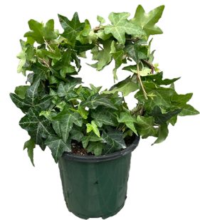 | 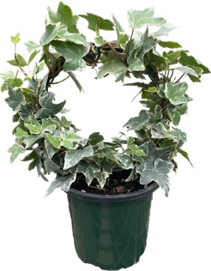 | 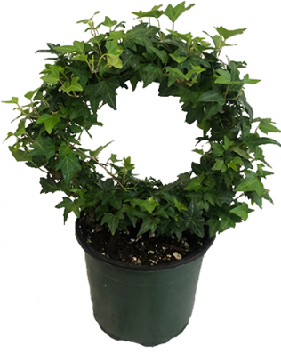 | 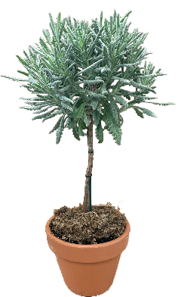 | 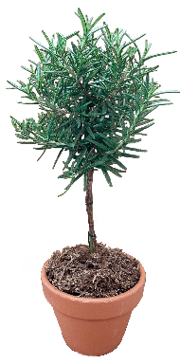 | 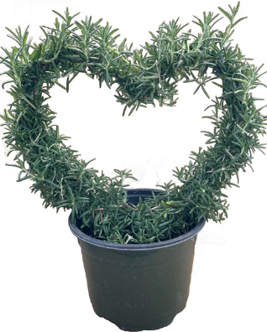
4.5” Green Ivy Hoop | 4.5” Variegated Ivy Hoop | 6.5” Green Ivy Hoop | 4” Lavender Standard | 4” Rosemary Standard | 6.5” Rosemary Heart

HERBS | Availability | Order Qty | Price
6.5” ROSEMARY TREE (approx. 16-18” high)
6.5” ROSEMARY TREE (with lights and clay pot)* |  | SOLD OUT
6.5” ROSEMARY TREE (with lights, decorations and clay pot)**
4” LAVENDER STANDARD (clay pot) (approx. 12-14” high) | 148 |  | $12.00 each
4” ROSEMARY STANDARD (clay pot) (approx. 12-14” high) | 439 |  | $12.00 each
10” LAVENDER STANDARD (approx. 24” high) (TRUCK or LTL only) |  | SOLD OUT
6.5” ROSEMARY HEART (8” heart) | 36 |  | $16.00 each
2.5” ROSEMARY UPRIGHT (variety) (32 pots per tray, 16 pot minimum) | 46 TRAYS |  | $1.30 each
2.5” ROSEMARY PROSTRATE (32 pots per tray, 16 pot minimum) | 15 TRAYS |  | $1.30 each
4” ROSEMARY UPRIGHT (variety) (10 pots per tray) | 50 TRAYS |  | $2.20 each
4” ROSEMARY PROSTRATE (10 pots per tray) | 19 TRAYS |  | $2.20 each
*Includes: 3.3’ strand of lights (battery included), and 6” clay pot **Includes: 1yd strand of lights (battery included), 5’ strand of tinsel (assorted gold, silver and red), 20 multicolored jingle bell ornaments with string to hang and 6” clay pot.
IVY
2.5” IVY POT – Green (32 pots per tray, 16 pot minimum) | 18 TRAYS |  | $1.45 each
2.5” IVY POT – Green/White Variegated (32 pots per tray, 16 pot minimum) | 15 TRAYS |  | $1.45 each
4.5” IVY HOOP – Green (5” hoop) | 144 |  | $8.00 each
4.5” IVY HOOP – Green/White Variegated (5” hoop) | 113 |  | $8.00 each
6.5” IVY HOOP – Green (8” hoop) | 136 |  | $15.00 each
6.5” IVY HOOP – Green/White Variegated (8” hoop)
6.5” IVY HEART – Green (8” heart)
6.5” IVY HEART – Green/White Variegated (8” heart) |  | SOLD OUT
8” IVY SPHERE – Green
8” IVY CONE – Variegated (10” cone)
(See additional pictures on the following page)

ADDITIONAL PICTURES
IVY
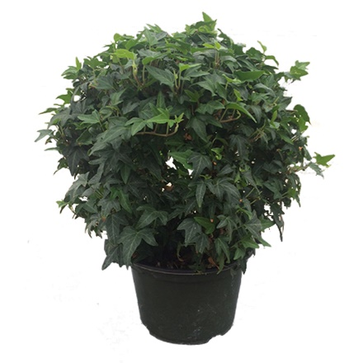  8” Green Ivy Sphere | 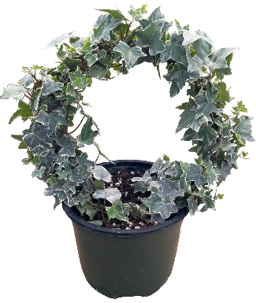  6.5” Variegated Ivy Hoop | 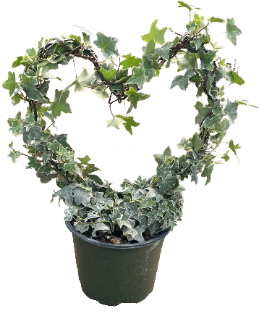  6.5” Variegated Ivy Heart | 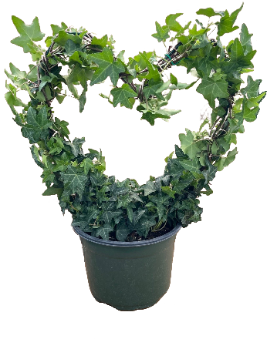  6.5” Green Ivy Heart

PACKING AND SHIPPING
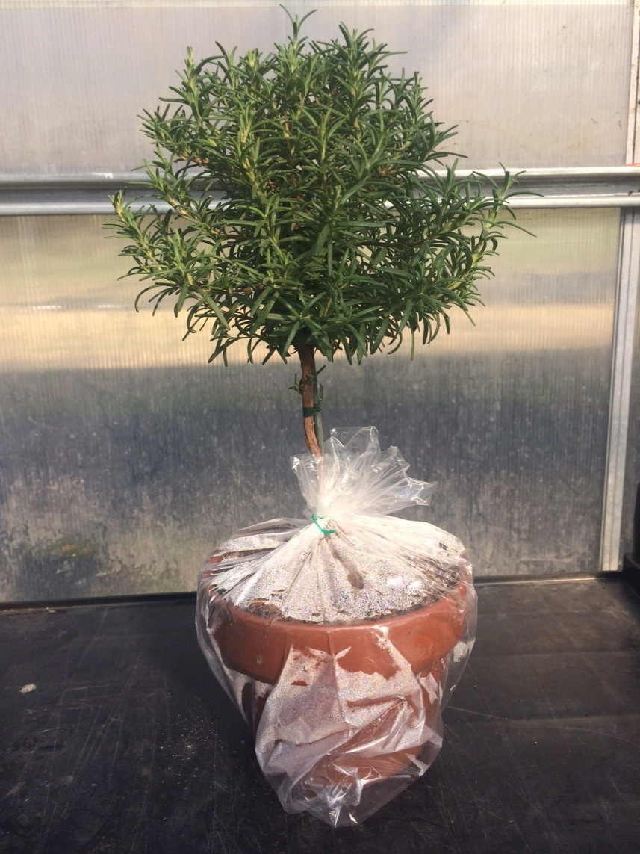
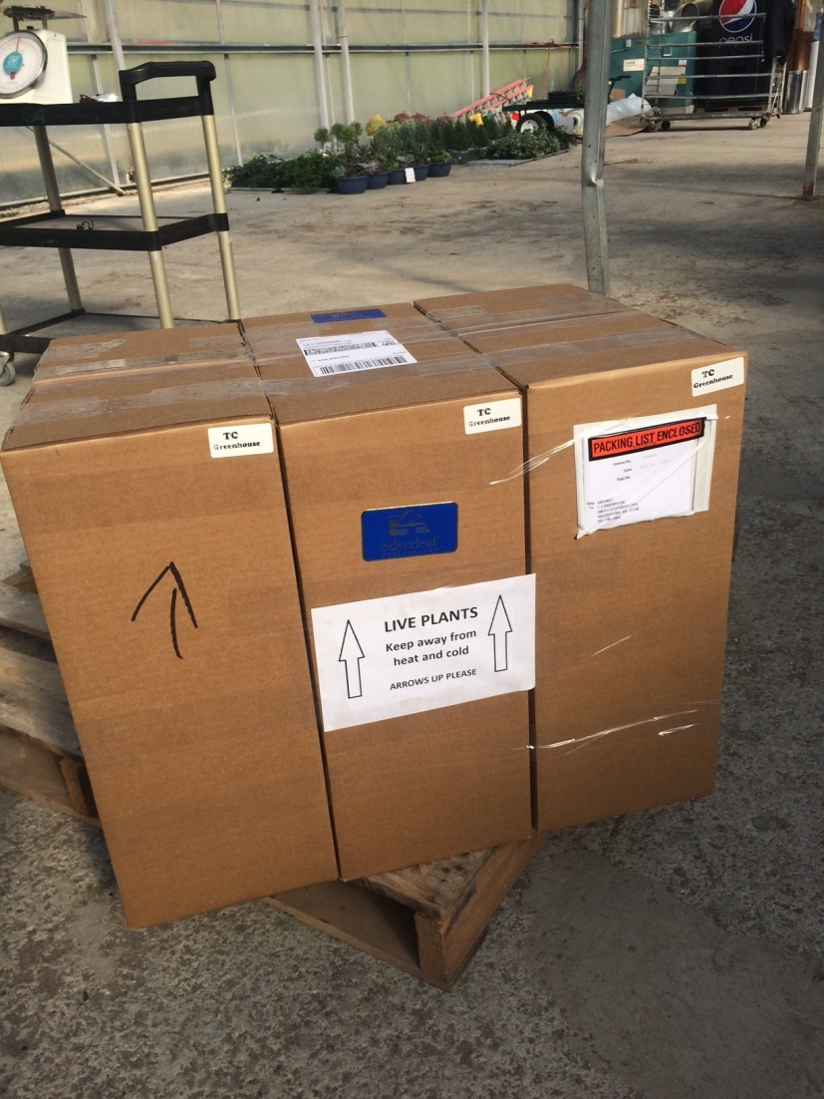
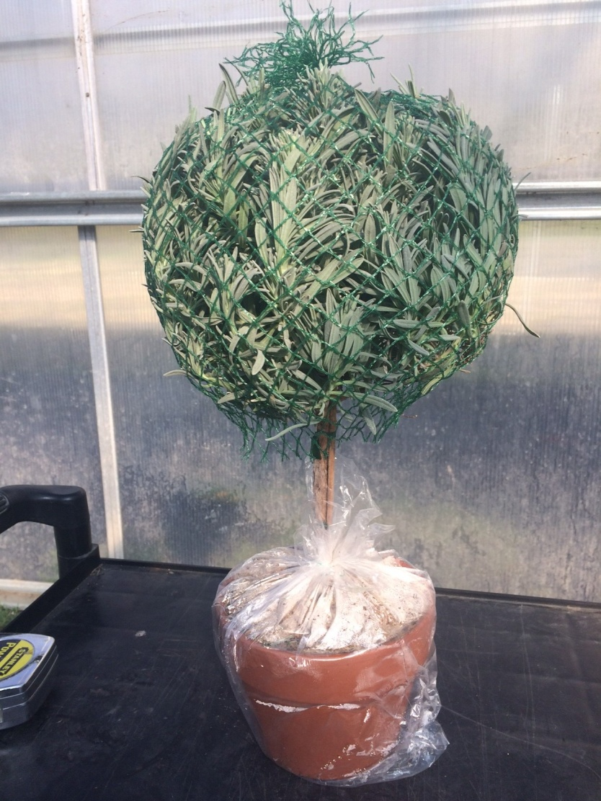
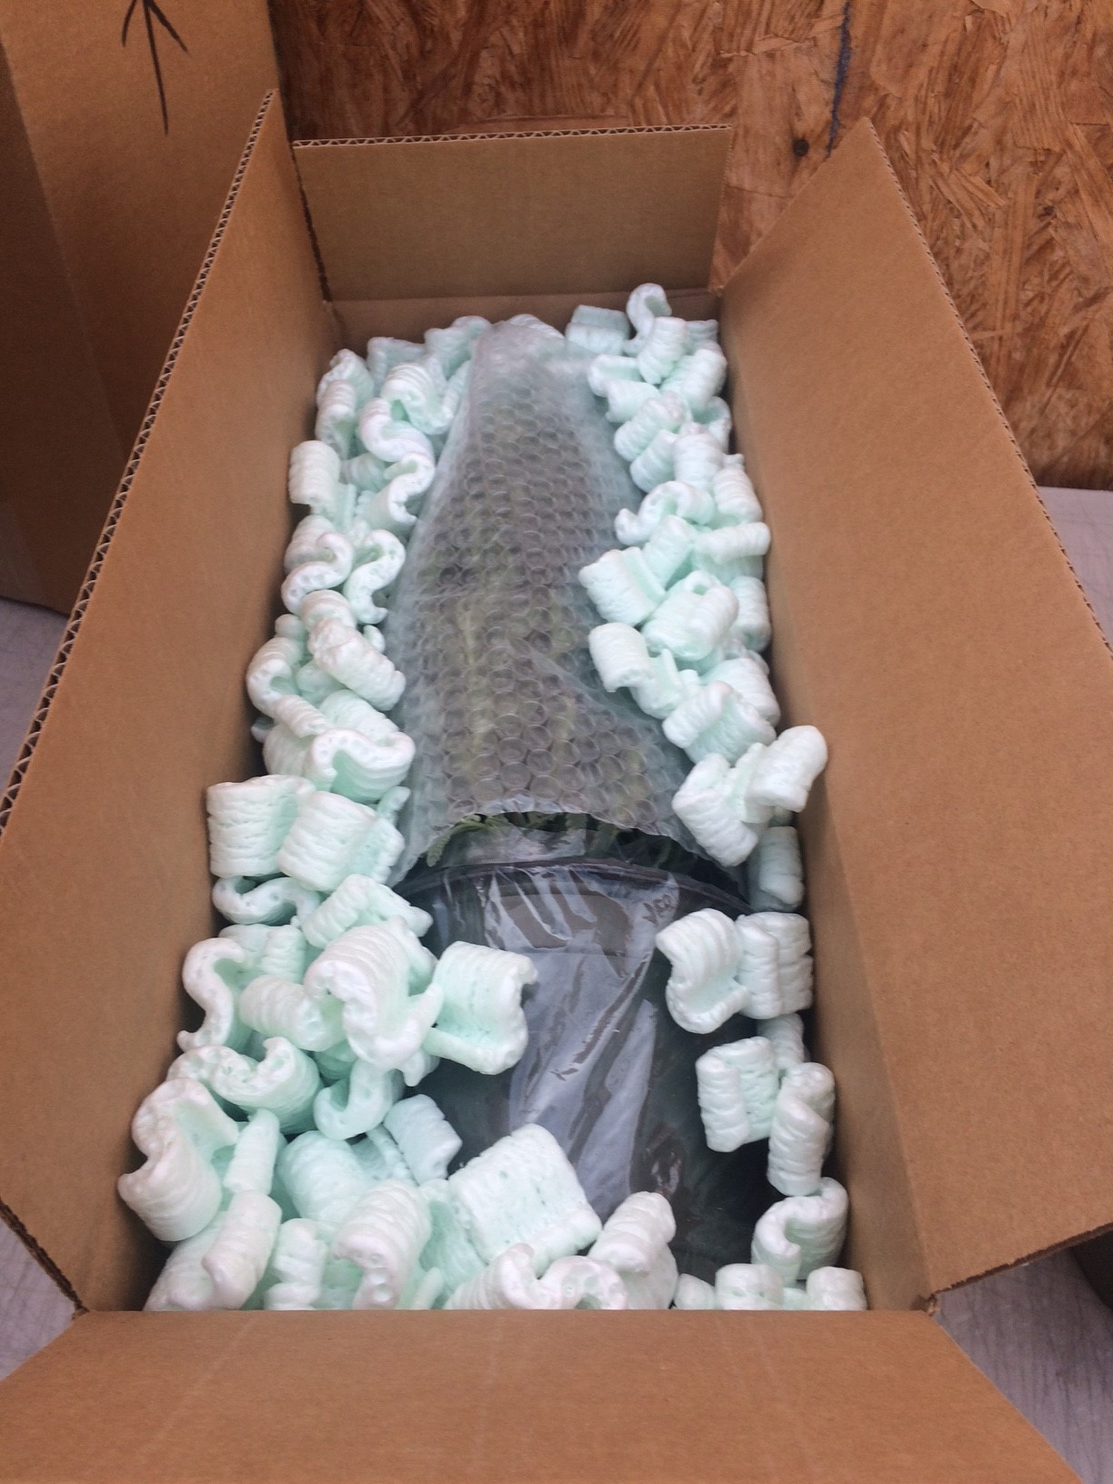
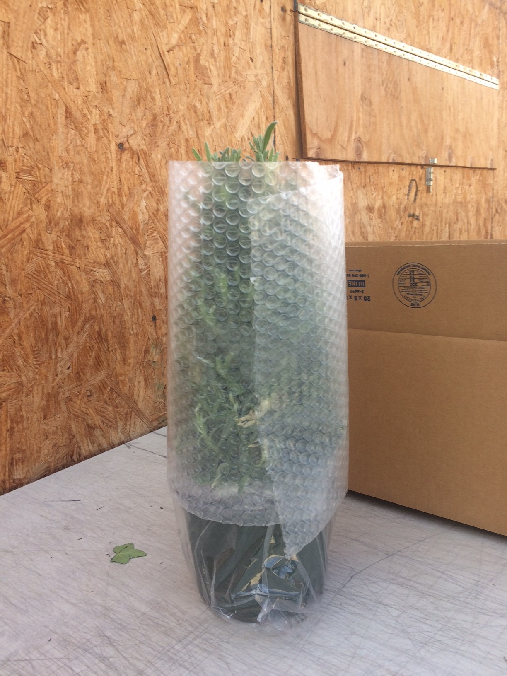

Small orders ship via FedEx, we can ship as little as 1 plant or up to 6 plants strapped together to make 1 box.

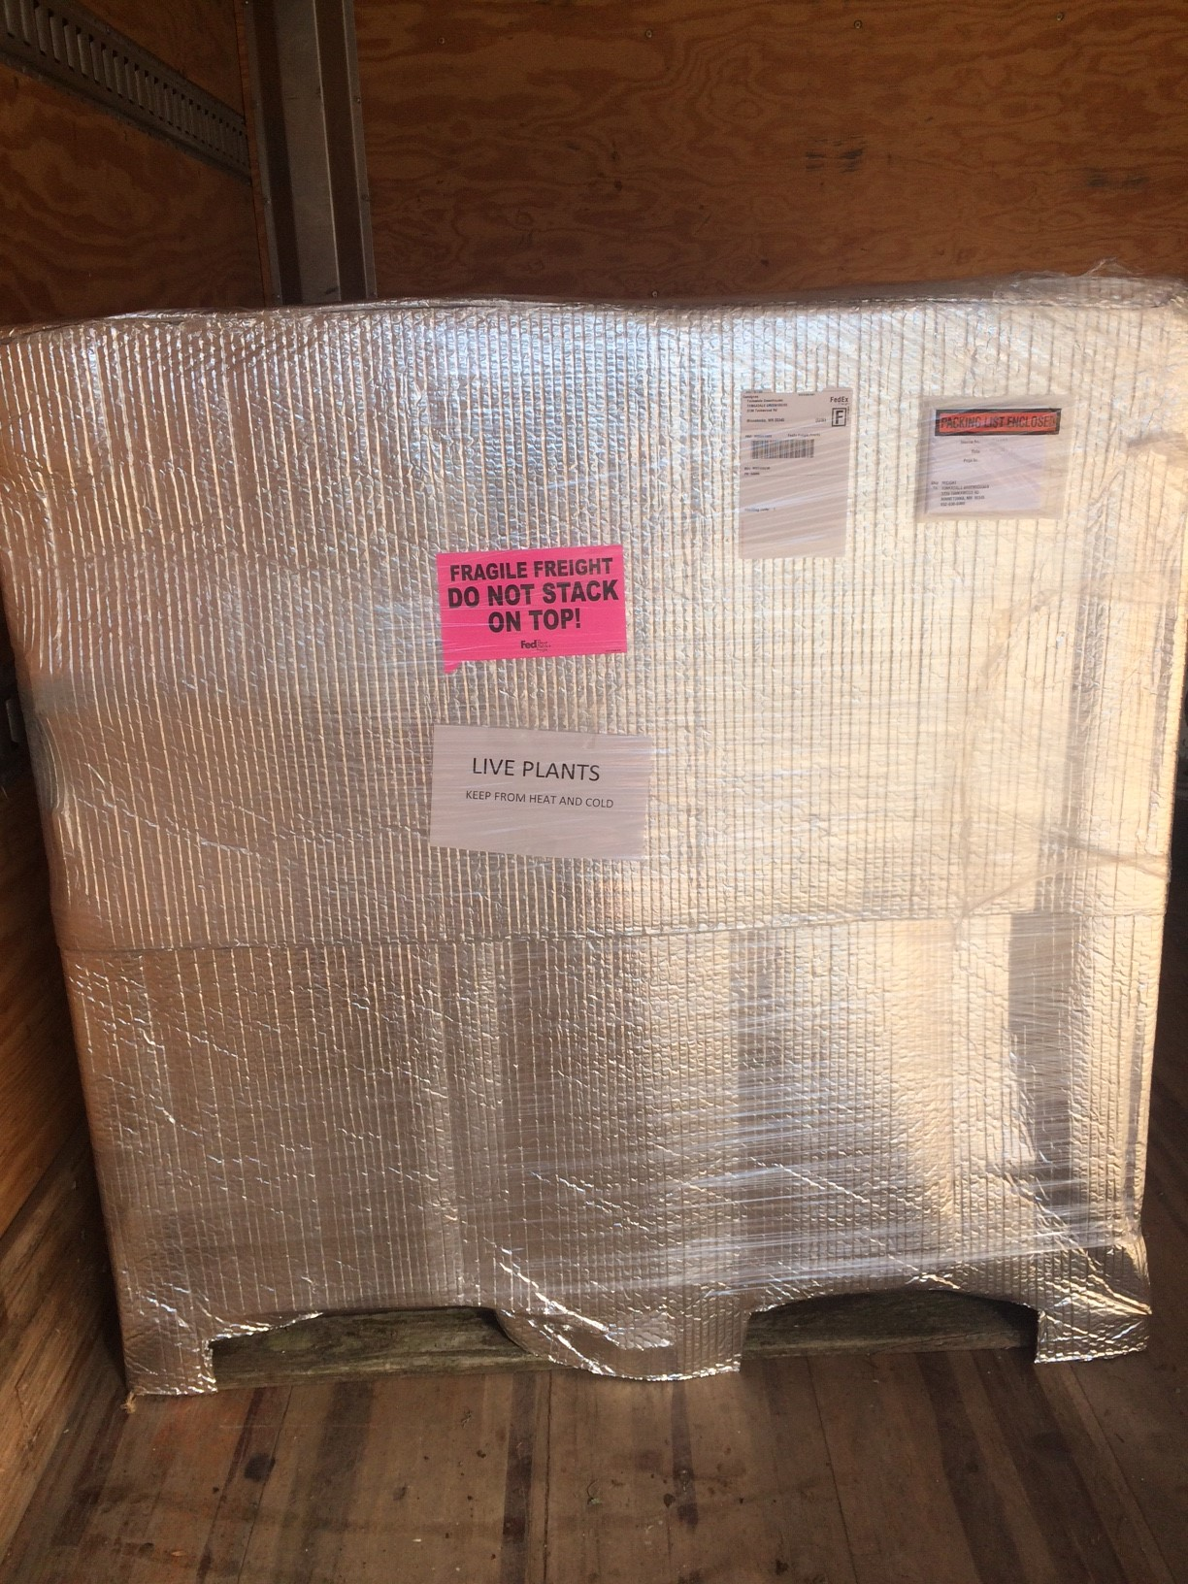
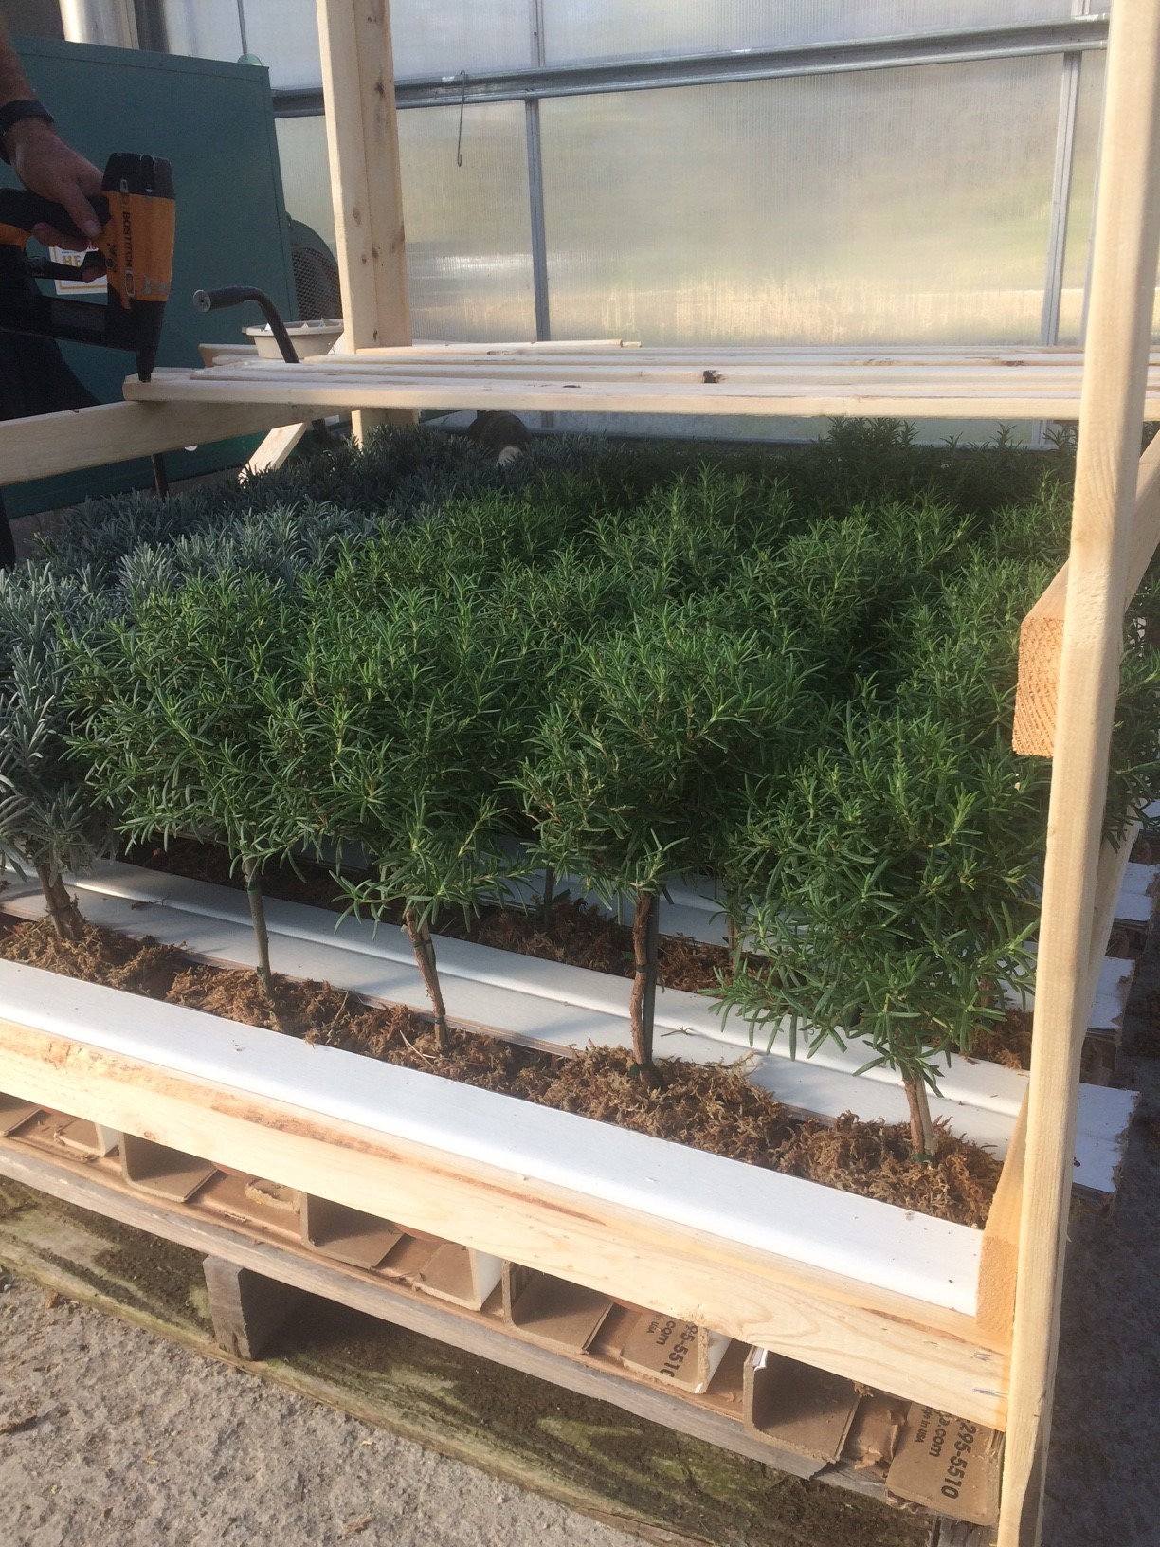
Item | # Per Pallet Shelf
2.5” Pots | 256 pots / 8 trays
4” Pots / 4.5” Hoops | 100 pots / 10 trays
6.5” Tree | 36 pots / 6 trays
6.5” Hoop / 6.5” Globe | 36 pots
6.5” Heart | 36 pots
8” Sphere | 24 pots
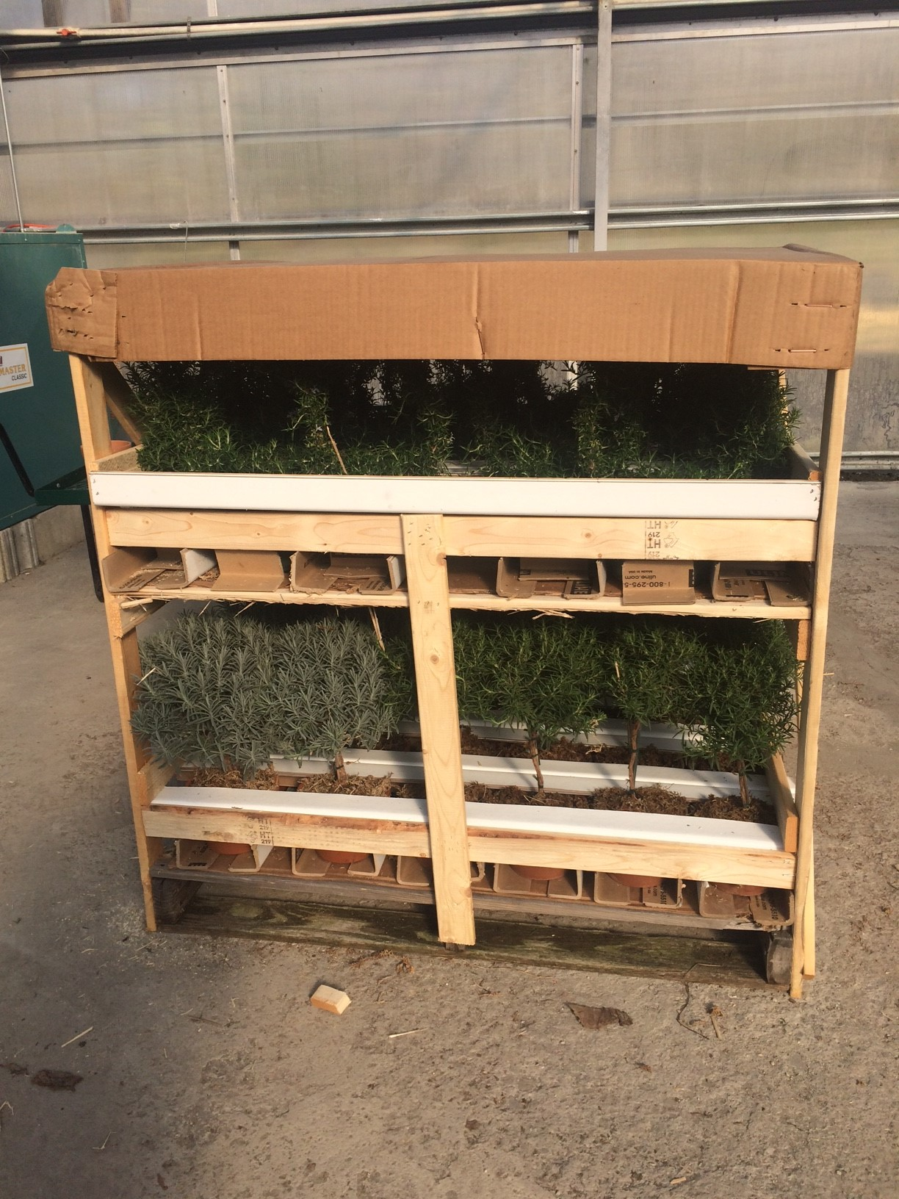

Larger orders ship palletized via FedEx Priority Freight.

Item | # Per Cart Shelf
2.5” Pots | 192 pots / 6 trays
4” Pots / 4.5” Hoops | 84 pots / 7 trays
6.5” Tree | 30 pots
6.5” Hoop / 6.5” Globe | 30 pots
6.5” Heart | 30 pots
8” Sphere | 20 pots
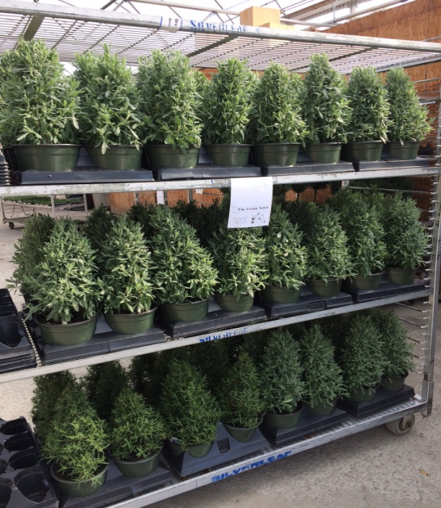
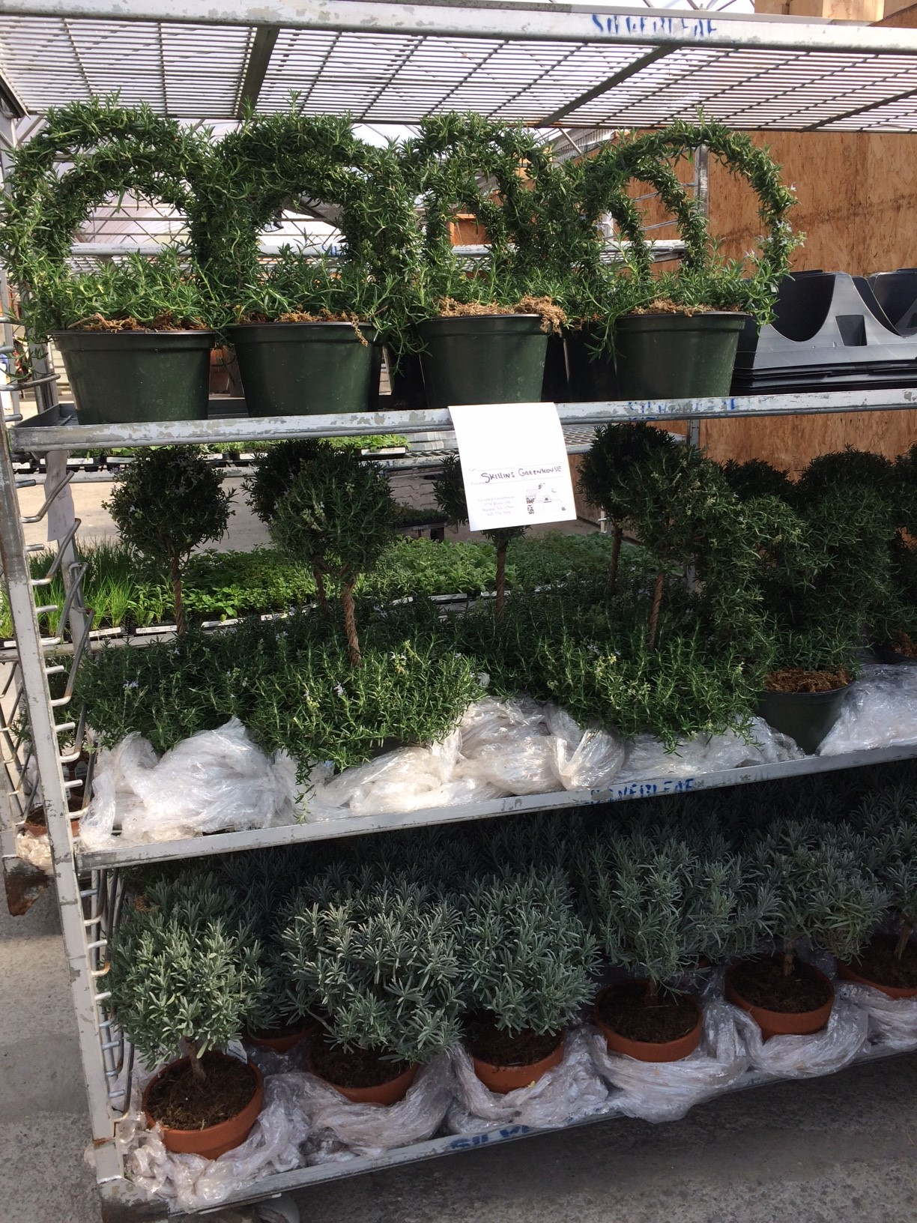

And of course, Silverleaf grower truck delivery is available throughout the local region.

